FINAL EXAMINATION
TIME ALLOWED: 90’
Subject: Linear Algebra.
No books allowed.
1/ Find the matrix , such that 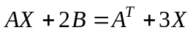, where 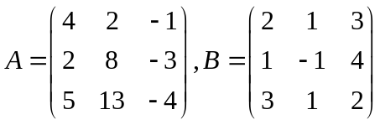.

2/ Compute the determinant of the matrix 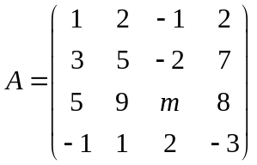.

3/ In 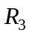 with the inner product ,
given the subspace 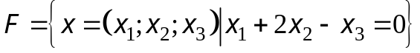.
Find one basis and a dimension of the orthogonal complement 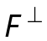 of the subspace F.

4/ Let 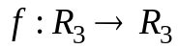 be the linear transformation.
Assume that .
a/ 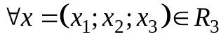, find 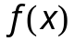.
b/ Find one basis and a dimension of the kernel of the mapping 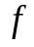.

5/ Let be the linear transformation and
.
a/ Find the matrix  of the linear transformation f in the basis 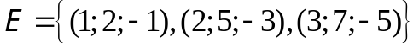.
b/ Using the matrix A, compute 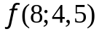.

6/ Diagonalize the matrix 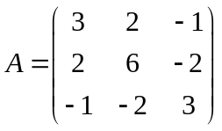, if possible.

7/ Make a change of variables that transforms the quadratic form
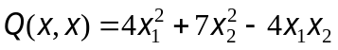 into the canonic form (using the orthogonal diagonalization method).

-----------------------  -----------------------

